

Name: Muhammad Umar

Class ID: 16798

Section: SC

Assignment: FOP Lab Major

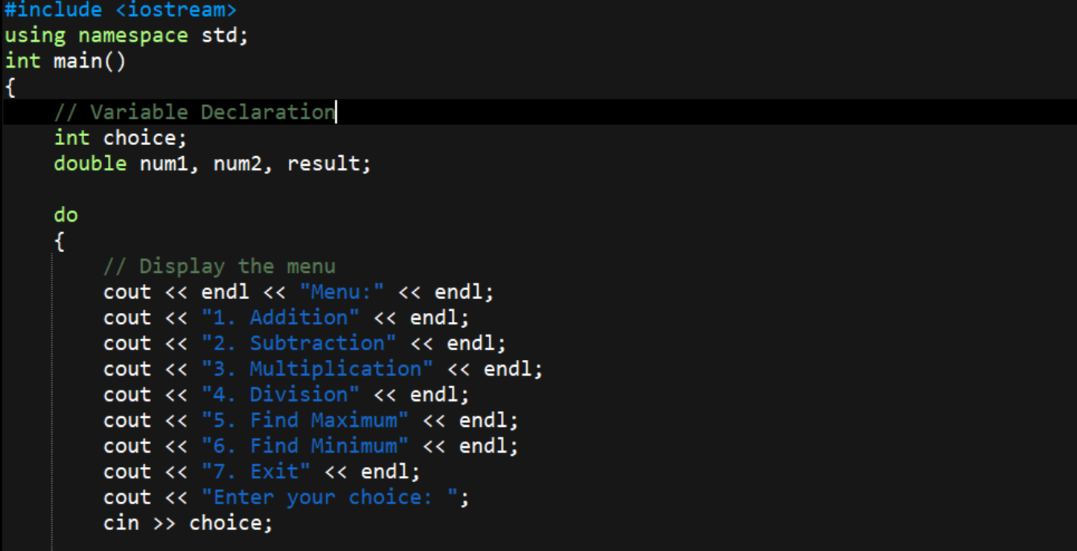

* Choice (an integer) will store the user's menu selection.
* num1 and num2 (of type double) will store the two numbers entered by the user. Result (of type double) will store the result of the chosen operation.
* The program uses a do-while loop to repeatedly display the menu and process user input until the user chooses to exit.
* The program prints a menu of options for the user:
  + Perform addition
  + Perform subtraction
  + Perform multiplication
  + Perform division
  + Find the maximum of two numbers
  + Find the minimum of two numbers
  + Exit the program
* The program then prompts the user to enter their choice.
* The user enters their menu choice, which is stored in the choice variable.
* If choice equals 7, the program will exit the loop and terminate.

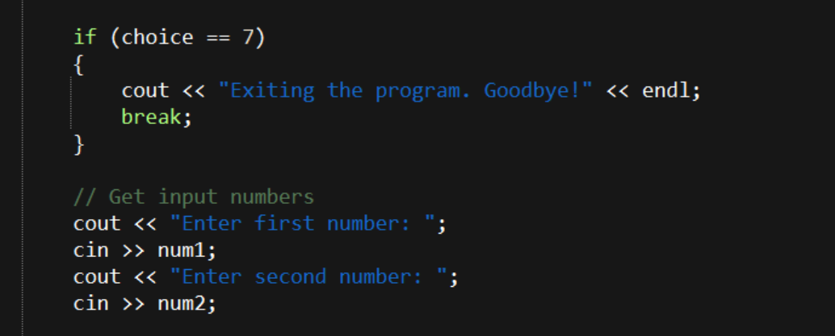

* This condition checks if the value of choice is 7.
* If true:
  + The program displays a message, **"Exiting the program. Goodbye!"**.
  + The break statement is executed, which immediately exits the do-while loop and stops the program.
* If the user chooses an operation (not exiting), the program prompts them to enter two numbers.
  + **Prompt for the first number**:
    - The program displays the message, **"Enter first number:"**.
    - The user inputs a value, which is stored in the variable num1.
  + **Prompt for the second number**:
    - The program displays the message, **"Enter second number:"**.
    - The user inputs a value, which is stored in the variable num2.

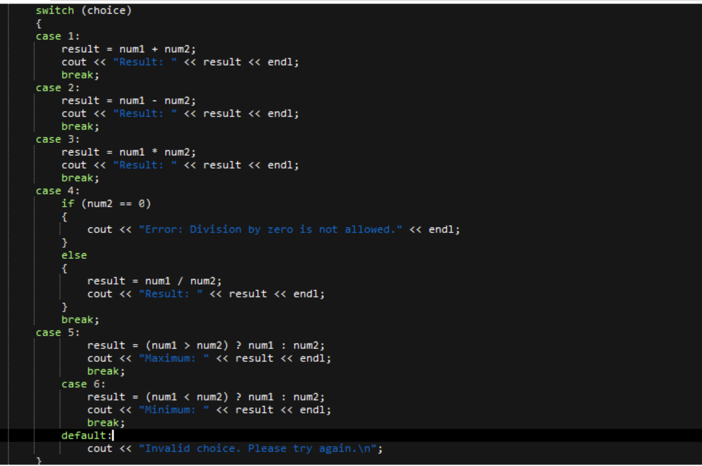

* The switch statement evaluates the value of choice and executes the corresponding case.
* Adds num1 and num2, stores the result in result.
* Prints the result to the user.
* The break statement exits the switch after this case is executed.
* Subtracts num2 from num1 and stores the result in result.
* Prints the result.
* Exits the switch.
* Subtracts num2 from num1 and stores the result in result.
* Prints the result.
* Exits the switch.
* Checks if num2 is 0:
  + If true, prints an error message because division by zero is undefined.
  + Otherwise, performs division (num1 / num2) and stores the result in result.
* Prints the result if division is valid.
* Exits the switch.
* Uses a **ternary operator**:
  + If num1 > num2, assigns num1 to result.
  + Otherwise, assigns num2 to result.
* Prints the maximum of the two numbers.
* Exits the switch.
* Uses a **ternary operator**:
  + If num1 < num2, assigns num1 to result.
  + Otherwise, assigns num2 to result.
* Prints the minimum of the two numbers.
* Exits the switch.

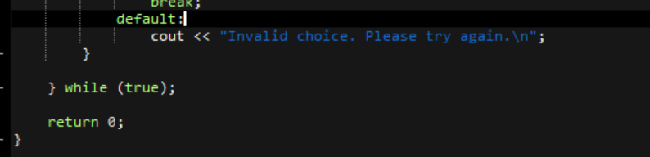

* **default:**  
  This is the default case of the switch statement. It is executed when none of the specified case labels match the input.
* **cout << "Invalid choice. Please try again.\n";**  
  This outputs the message "Invalid choice. Please try again." to the console, indicating that the user entered an unrecognized option.
* **while (true);**  
  This is the closing part of a do-while loop. The do-while loop repeatedly executes the block of code until the condition becomes false. In this case, the condition is true, meaning the loop will continue indefinitely unless a break statement is encountered inside the loop.
* **return 0;**  
  This indicates the end of the program. Returning 0 typically signifies that the program executed successfully without errors.